Amazon – Tax Exempt Procedure
You will need to set up an account. On the first screen, click on Create your Amazon account:
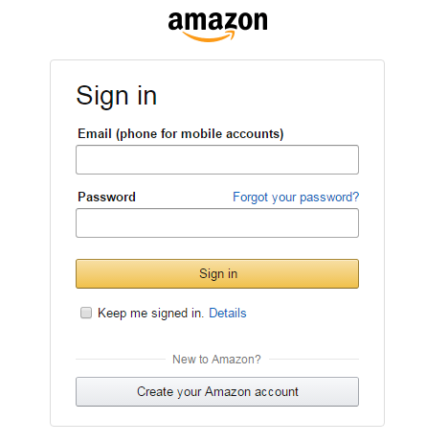
Fill in your name, your email (must be your @maine.edu email), create a password, re-enter your password:
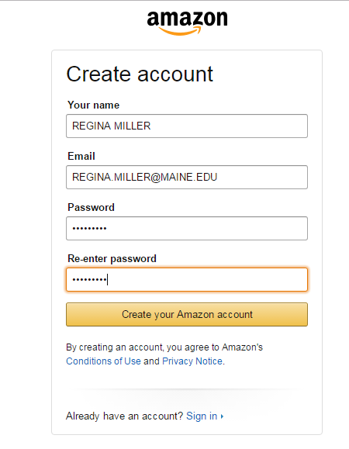

Go into your account information (towards the upper right hand corner)
Choose to Amazon Business
From this screen, click Create a Free Account:
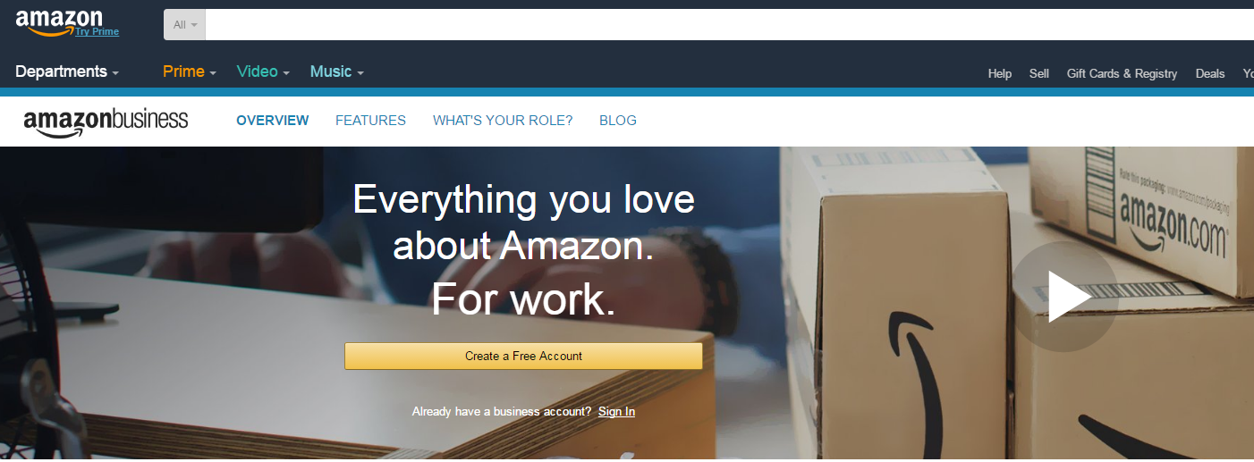

Click yes:
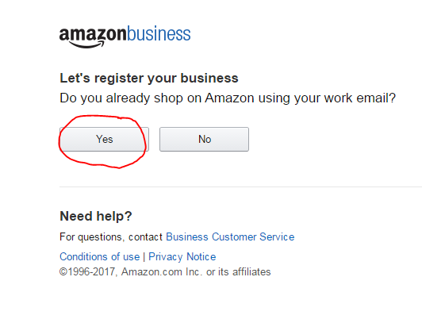
Sign in with your work email and your password:
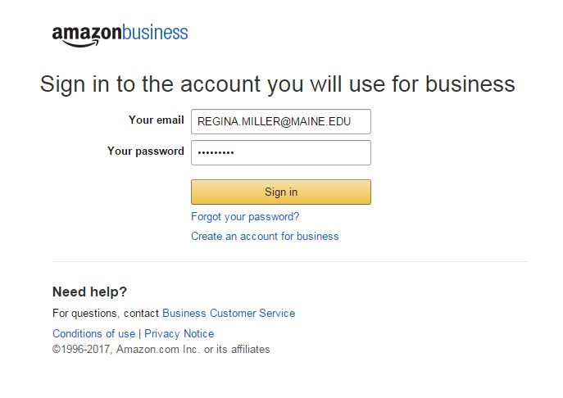
Enter your mailing information:
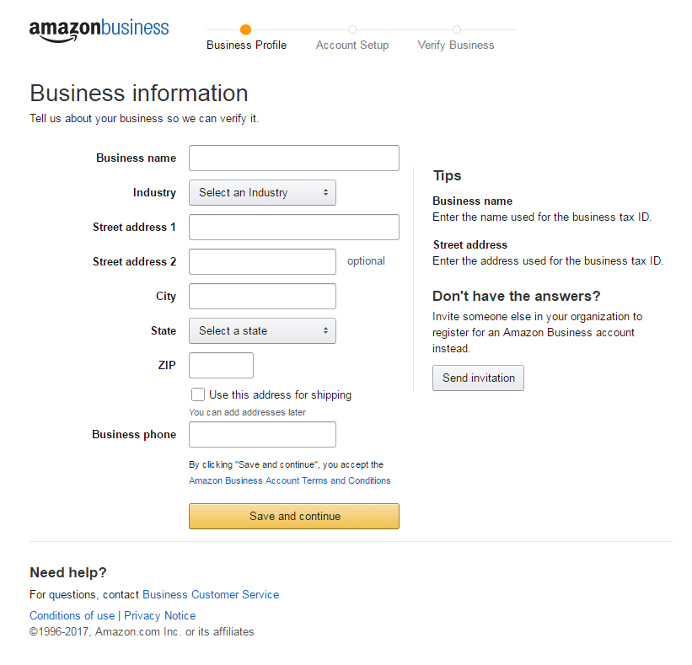

Enter Business Tax ID – 01-6000769:
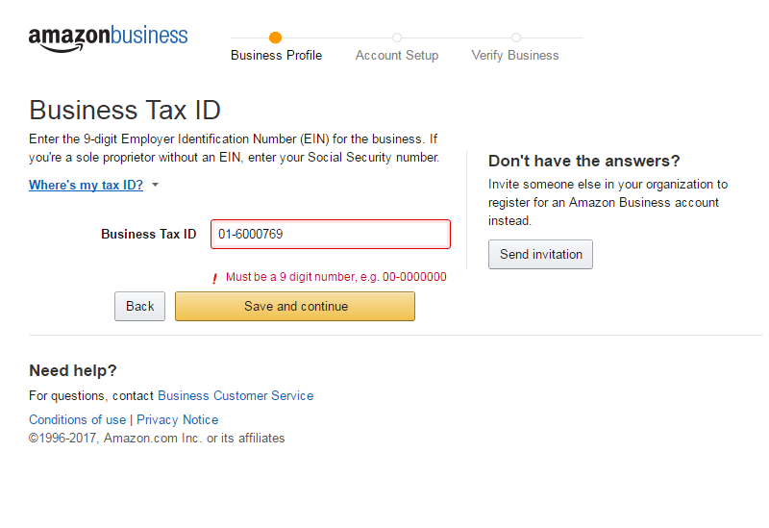
Enter your contact information:
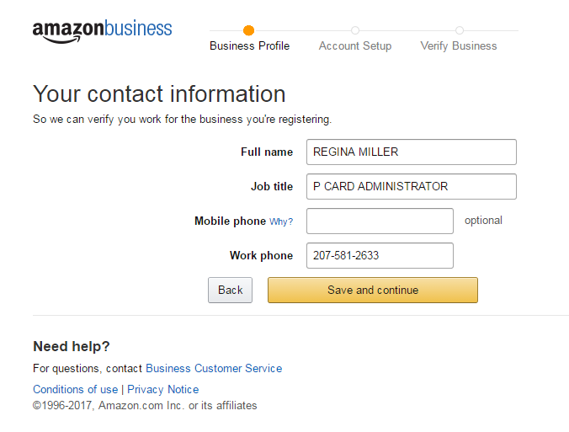
You can enter you Purchasing Card Information and the billing address is 5761 Keyo Building, Orono, ME 04469:
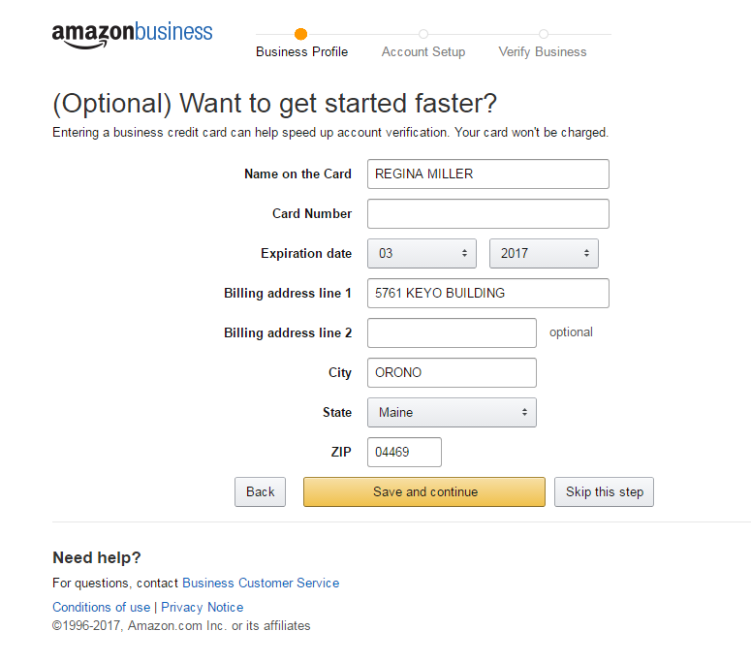
Choose to use your existing account (the one you just set up):
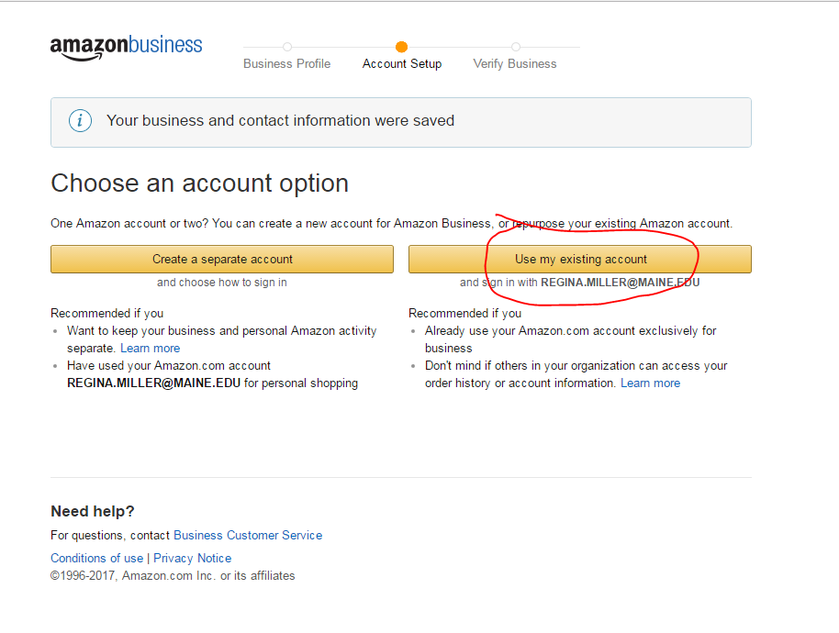
Confirm and Continue:
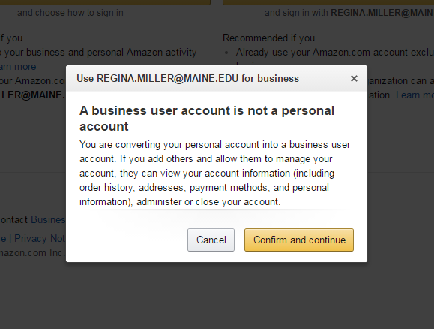

Complete your registration:
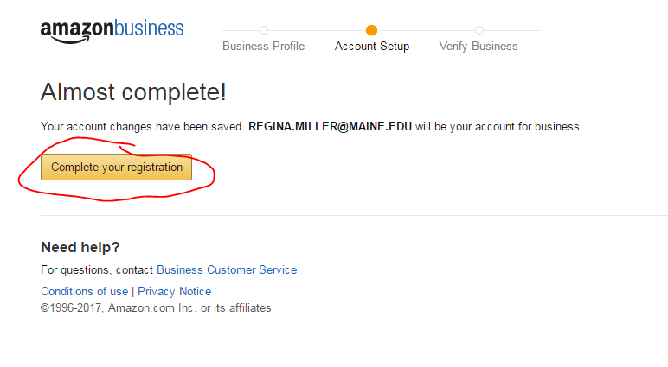

It may take some time to verify your account:
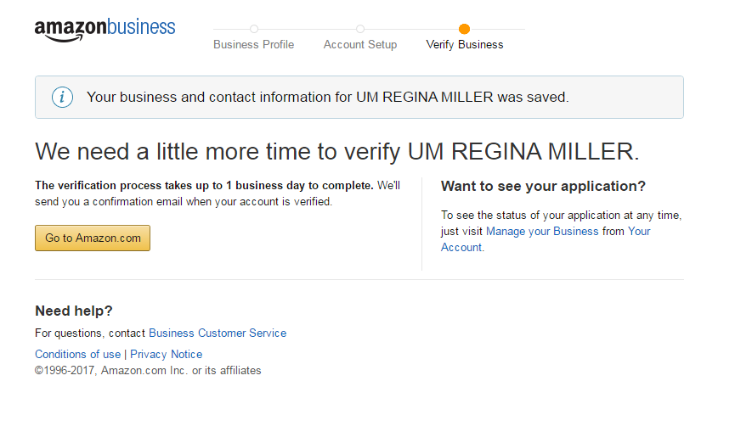
You will receive an email:
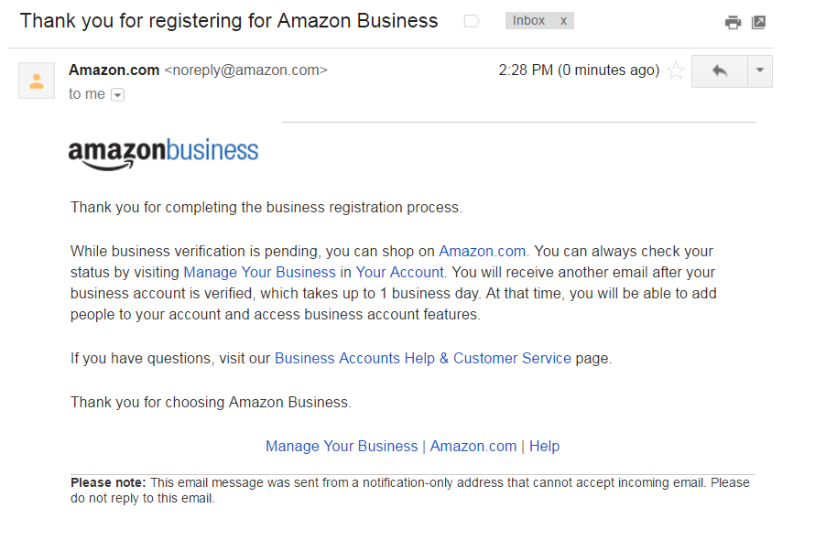

After completing the steps in "Amazon-tax-exempt-how-to" from the faculty and staff resource page (https://forest.umaine.edu/news-resources/faculty-staff-resources/), you then need to:

1) login to your amazon business account
2) in the top right, hover where it says "Hello, first name"
3) click Business settings
4) near the bottom click "Tax exemption"
5) Click "Add tax exemption"
6) Select "Maine"
7) Select "Non-profit"
8) then upload a completed and signed copy of "Maine sales tax exemption form" from the faculty and staff resource page
9) Amazon will email you once the tax exemption is complete (this may take a couple of hours)

